Student name: YIZHENG HE

Student ID:221411294

SIT123: Data Capture Technologies

# Lab Report 3.1:

# Using the Data Logger Shield in Arduino (30 marks)

In this task, we will learn about using an SD card to save sensor data.

## Pre-requisites: You must do the following before this task

1. **Attend Class (Lecture) & Seminar**
2. **Lab report 2**
3. **Read** [**https://learn.adafruit.com/adafruit-data-logger-shield/using-the-real-time-clock**](https://learn.adafruit.com/adafruit-data-logger-shield/using-the-real-time-clock)
4. **Read this sheet from top to bottom**

## Due Date Friday 5:00pm, 12th August 2022

## Task Objective

In this task, you will write a program to detect motion and save the detected motion readings to an SD card, using a data logger shield.

## Hardware Required

* Arduino Board
* USB cable
* SD Card (SanDisk 16Gb Ultra SDHC Memory Card)
* Data Logging Shield for Arduino
* CR1220 Coin Cell Battery
* HCSR505 PIR Passive Infra Red Motion Detector

## Task Submission Details

There are 3 questions in this task. Answer all of them in this word document itself and submit to unit site.

### **Q1. Follow the steps in “Setting Up The SD Card Activity Sheet”. At the end of activity, take a screenshot of the Serial Monitor and include here.**

(5 marks)

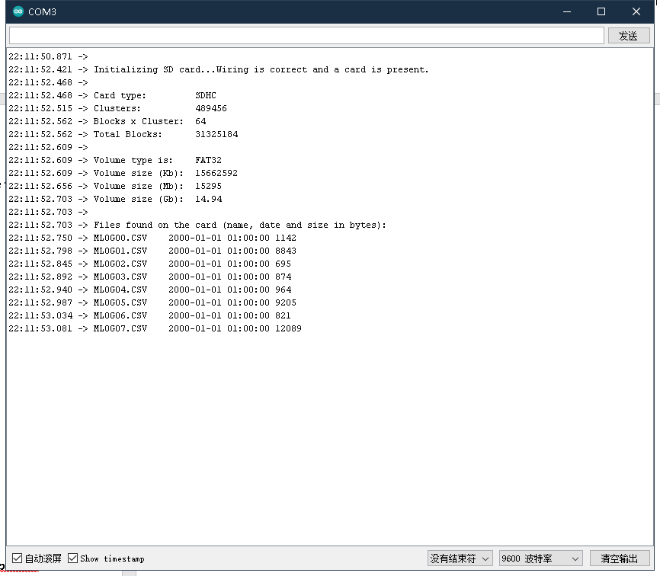

### **Q2. Follow the steps in “Using the Real Time Clock Activity Sheet”.**

1. At the end of activity, take a screenshot of the Serial Monitor and include here. (6 marks)

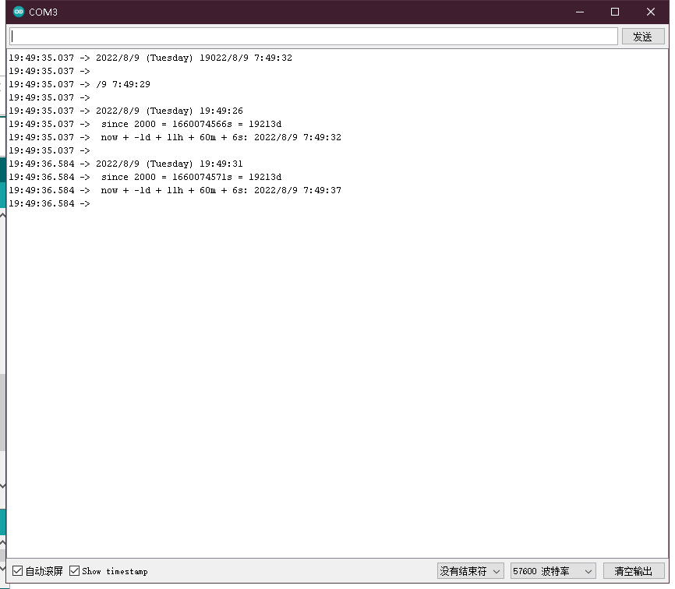

1. Examine the code. What does the following line of code do?

DateTime now = rtc.now();

This function returns a DateTime object that describes the year, month, day, hour, minute, and second when now() was called on that object.

(Hint: refer to <https://learn.adafruit.com/adafruit-data-logger-shield/using-the-real-time-clock> )

(4 marks)

### **Q3. Now you are ready to start logging data to file! Follow the steps in “Saving Motion Data Activity Sheet”.**

1. At the end of activity, take a screenshot of the Serial Monitor and include here.

(5 marks)

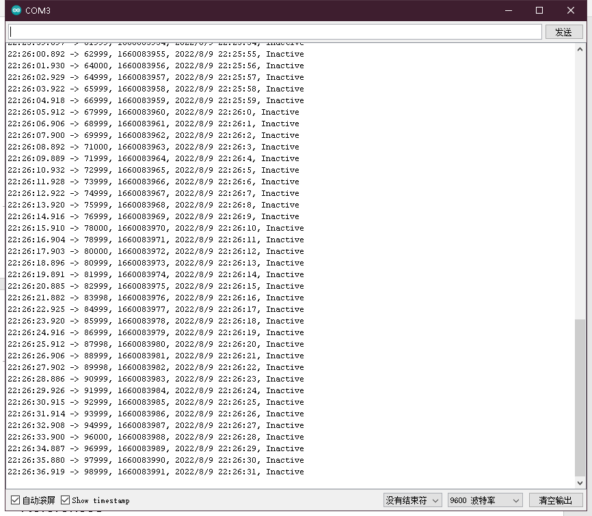

1. Run your program. Wave your hand in front if the motion sensor and observe the ‘Active’ state, then stop and wait until you see an ‘Inactive’ state on the Serial Monitor. Keep doing this for three minutes so that you get both ‘Active’ and ‘Inactive’ data. At the end of three minutes, unplug the USB. This will switch off the Arduino board. Next, retrieve the .csv file containing motion sensor data from the SD card. Upload the .csv file with this report to unit site.

(10 marks)

## References

<https://learn.adafruit.com/adafruit-data-logger-shield/using-the-sd-card>